ASSINGMENT 4

Name – Abhinav Tongale

Roll no -2

Question –

1. CDAC YCP has certain number of batches. each batch has certain number of students

accept number of batches. for each batch accept number of students.

create an array to store mark for each student (1 student has only 1 subject mark)

accept the marks.

display the marks.

Code -

using System;

using System.Transactions;

namespace Assignment4Q1

{

internal class Program

{

public static void Main()

{

Main1();

}

static void Main1()

{

Console.WriteLine("enter the number of batches");

int numBatches = int.Parse(Console.ReadLine());

int[][] batchMarks

= new int[numBatches][];

for (int i=0; i<numBatches; i++)

{

Console.WriteLine("Enter the number of students in batch {0}: ", i+1);

int numStudents=int.Parse(Console.ReadLine());

batchMarks[i]=new int[numStudents];

for (int j=0; j<numStudents; j++)

{

Console.WriteLine("Enter the number of student {0} in batch {1}: ", j + 1, i + 1);

batchMarks[i][j] = int.Parse((string)Console.ReadLine());

}

}

Console.WriteLine(".NET marks are: ");

for(int i=0; i< numBatches; i++)

{

Console.WriteLine("Batch {0}: [{1}]", i+1 , string.Join(", ", batchMarks[i]));

}

Console.ReadKey();

}

}

}

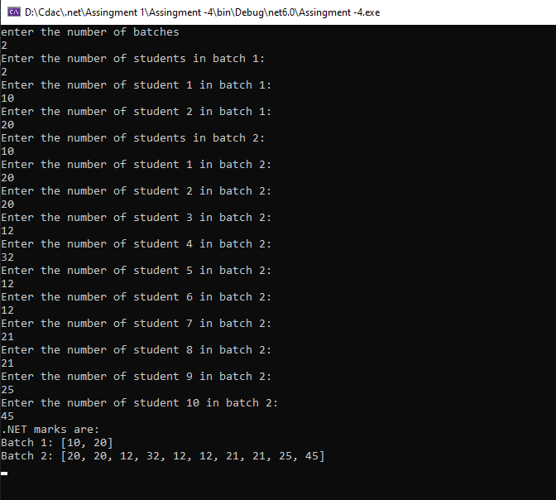

Question -

2. Create an array of Employee class objects

Accept details for all Employees

Display the Employee with highest Salary

Accept EmpNo to be searched. Display all details for that employee.

Code -

namespace Assignment4Q2

{

internal class Employee

{

public int EmpNo { get; private set; }

public string? EmpName { get; private set; }

public int EmpSalary { get; private set; }

static void Main()

{

Employee[] emp = new Employee[3];

for (int i = 0; i < emp.Length; i++)

{

emp[i] = new Employee();

Console.WriteLine("Enter the details of Employee {0}", i + 1);

Console.Write("Enter the Employee Number: ");

try

{

emp[i].EmpNo = int.Parse(Console.ReadLine());

}

catch (FormatException)

{

Console.WriteLine("Invalid input. Please enter a valid number.");

i--;

continue;

}

Console.Write("Enter the Employee Name: ");

emp[i].EmpName = Console.ReadLine();

Console.Write("Enter the Employee Salary: ");

try

{

emp[i].EmpSalary = int.Parse(Console.ReadLine());

}

catch (FormatException)

{

Console.WriteLine("Invalid input. Please enter a valid number.");

i--;

continue;

}

}

int max = emp[0].EmpSalary;

int index = 0;

for (int i = 1; i < emp.Length; i++)

{

if (emp[i].EmpSalary > max)

{

max = emp[i].EmpSalary;

}

index = i;

}

Console.WriteLine("The Employee with highest salary is: ");

Console.WriteLine("Employee Number: {0}", emp[index].EmpNo);

Console.WriteLine("Employee Name: {0}", emp[index].EmpName);

Console.WriteLine("Employee Salary: {0}", emp[index].EmpSalary);

Console.Write("Enter the Employee Number to be searched: ");

try

{

int eno = int.Parse(Console.ReadLine());

for (int i = 0; i < emp.Length; i++)

{

if (emp[i].EmpNo == eno)

{

Console.WriteLine("Employee Number: {0}", emp[i].EmpNo);

Console.WriteLine("Employee Name: {0}", emp[i].EmpName);

Console.WriteLine("Employee Salary: {0}", emp[i].EmpSalary);

}

}

}

catch (FormatException)

{

Console.WriteLine("Invalid input. Please enter a valid number.");

}

Console.ReadLine();

}

}

}

